# **Webhook Notifier Event Processing Solution**

## **1. Introduction**

The Webhook Notifier Event Processing Solution is designed to handle high-throughput event processing (up to 1 billion events per month) for a webhook notification system. This solution ensures three core principles: **Scalability**, **Reliability**, and **Fairness**. It leverages **Apache Kafka** as the message broker, **Redis** for rate limiting and deduplication, and incorporates retry mechanisms and circuit breakers for robust webhook invocation. The implementation uses **Java Spring** as the primary programming language, with **PostgreSQL** as the database. The entire system is deployed on a **Kubernetes (k8s)** cluster using Helm charts, with comprehensive monitoring via Loki, Grafana, and Prometheus.

This document outlines the architecture, processing flow, infrastructure, monitoring strategy, testing approach, and future improvements.

## **2. System Architecture**

### **2.1 Components**

* **Producer**: Pre-existing component within the webhook registration system, responsible for publishing events to a Kafka topic.
* **Consumer (Notifier)**: Processes events from Kafka in batches, ensuring scalability, reliability, and fairness.
* **Message Broker**: Apache Kafka, handling event queuing and distribution.
* **Rate Limiter & Deduplication**: Redis, used for rate limiting webhook calls and preventing duplicate event processing.
* **Database**: PostgreSQL, storing detailed event data for retrieval during processing.
* **Dead Letter Queue (DLQ)**: A Kafka topic for storing events that fail processing after retries or circuit breaker triggers.
* **Monitoring Stack**: Loki (log aggregation), Promtail (log collection), Grafana (visualization), and Prometheus (metrics collection).

### **2.2 Architecture Diagram**

The system architecture illustrates the interaction between components:

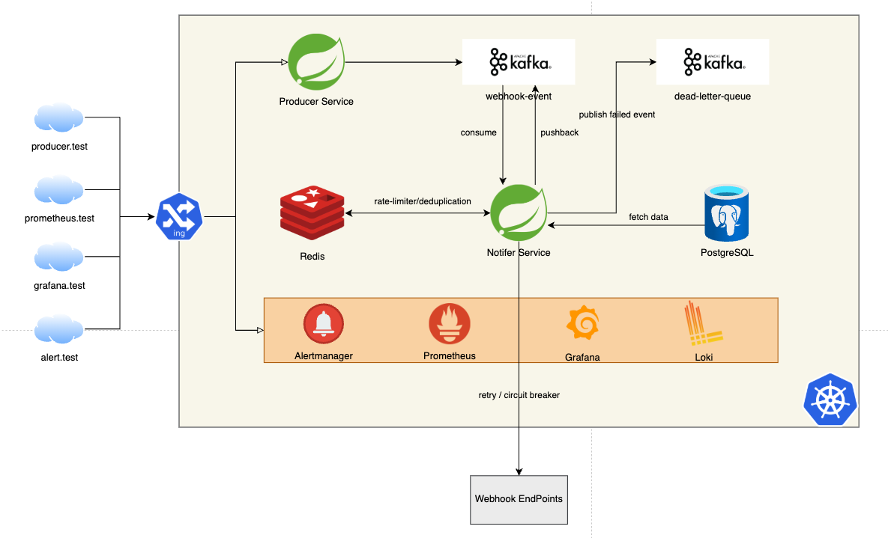

## **3. Event Processing Flow**

### **3.1 Overview**

The processing flow ensures efficient handling of events from production to webhook invocation, with safeguards for reliability and fairness.

### **3.2 Detailed Flow**

* **Event Production**:
  + The Producer publishes events to a designated Kafka topic.
* **Event Consumption**:
  + The Consumer retrieves events in batches (default: 100 events per batch) from Kafka.
  + Event data is fetched from PostgreSQL in bulk, supporting multiple event types.
  + Batch processing is parallelized using multi-threading for scalability.
* **Per-Event Processing**:
  + **Deduplication Check**: Queries Redis to identify duplicates; skips processing if detected.
  + **Rate Limiting Check**: Verifies against Redis rate limits; if exceeded, the event is re-queued to Kafka for later processing.
  + **Webhook Invocation**:
    - Executes HTTP calls to webhook endpoints with a retry mechanism (e.g., exponential backoff).
    - Implements a circuit breaker per webhook URL to prevent cascading failures.
    - On success: Proceeds to the next event.
    - On failure (after retries or circuit breaker activation): Pushes the event to the Dead Letter Queue (DLQ).
* **Batch Completion**:
  + If all events in the batch are processed successfully (no exceptions), the Consumer sends an acknowledgment (ACK) to Kafka, committing the offset.

### **3.3 Sequence Diagram**

The sequence diagram below outlines the event processing logic:

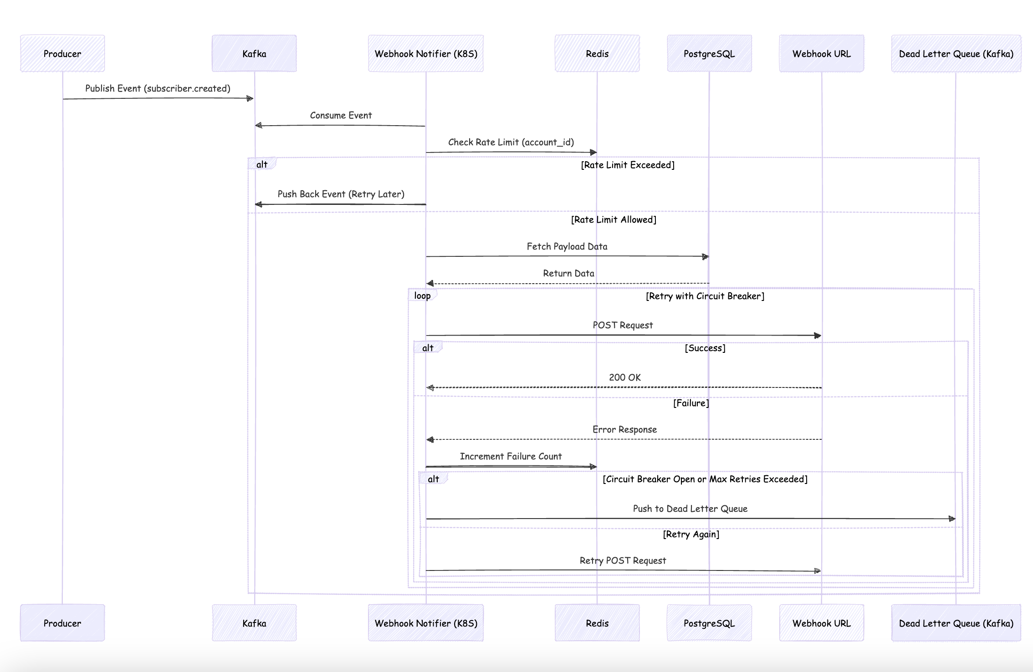

## **4. Infrastructure**

### **4.1 Deployment**

The system is deployed on a Kubernetes cluster using Helm charts for the following components:

* **Producer**: Publishes events to Kafka.
* **Consumer (Notifier)**: Processes events and invokes webhooks.
* Webhook Endpoints: Mock for test.
* **Kafka**: Message broker with configurable topics and partitions.
* **Redis**: In-memory store for rate limiting and deduplication.
* **PostgreSQL**: Persistent storage for event data.
* **Monitoring Stack**: Loki, Promtail, Grafana, Prometheus and Alertmanager.

### **4.2 Configuration**

* **Kafka**: Configured for high throughput and durability (e.g., multiple partitions, replication factor).
* **Redis**: Optimized for low-latency key-value operations.
* **k8s**: Auto-scaling enabled for Consumer pods based on workload.

## **5. Monitoring and Observability**

### **5.1 Logging**

* **Tools**: Loki for log aggregation, Promtail for log collection.
* **Visualization**: Grafana dashboards displaying log data.

### **5.2 Metrics**

* **Collector**: Prometheus.
* **Defined Metrics**:
  + kafka.batch.processing.time: Duration to process a Kafka batch (ms).
  + kafka.event.count: Total events processed.
  + webhook.execution.count: Total webhook invocation attempts.
  + webhook.success.count: Successful webhook calls.
  + webhook.failure: Failed webhook calls.
  + webhook.circuit.open: Instances of circuit breaker activation.

### **5.3 Alerts**

Alerts are configured in Prometheus using Alertmanager to notify teams of critical conditions. Below are example configurations for key metrics:

#### **5.3.1 High Batch Processing Time**

* **Metric**: kafka.batch.processing.time
* **Condition**: Batch processing time exceeds 500ms for 5 minutes.
* **Action**: Notify the operations team to investigate Consumer performance or Kafka lag.

#### **5.3.2 High Webhook Failure Rate**

* **Metric**: webhook.failure and webhook.execution.count
* **Condition**: Webhook failure rate exceeds 10% over 10 minutes.
* **Action**: Escalate to the team to check webhook endpoints or circuit breaker states.

#### **5.3.3 Circuit Breaker Activation**

* **Metric**: webhook.circuit.open
* **Condition**: Any circuit breaker opens for more than 5 minutes.
* **Action**: Investigate specific webhook URLs and coordinate with vendors if necessary.

#### **5.3.4 Low Event Processing Throughput**

* **Metric**: kafka.event.count
* **Condition**: Event processing rate drops below 100 events/second for 15 minutes.
* **Action**: Check Consumer pod scaling and resource utilization.

### **5.4 Notification Channels**

* Alerts are routed via Alertmanager to channels such as Slack, email, or PagerDuty, based on severity (warning or critical).

## **6. Testing**

### **6.1 Unit Testing**

* **Coverage**: Partial unit tests implemented for key components (e.g., Consumer logic, webhook retry).
* **Limitation**: Not 100% coverage due to effort constraints.

### **6.2 Performance Testing**

* **Tool**: JMeter.
* **Scenario**: Simulated bunch of API requests to the Producer, publishing events to Kafka.
* **Results**: We will determine how many events it can process in a minute for an instance -> adjust config for batch size, thread pool size, rate limit size... to tuning performance

### **6.3 Test Data Generation**

* **Tools**: Custom Python scripts to generate test data and CSV files for JMeter.

## **7. Benchmark Results**

* **Test Setup**: 896 API requests via JMeter to simulate event production.
* **Observations**: Initial tests confirm basic functionality; full performance metrics (e.g., throughput, latency) to be documented after extended runs.
* **Scalability Target**: Validation for 1 billion events/month pending.

## **8. Future Improvements (To-Do)**

* **Optimize Batch Processing**:
  + Fine-tune batch size and thread pool configurations to maximize throughput and minimize latency.
* **Advanced DLQ Handling**:
  + Implement retry policies for DLQ events and a manual intervention workflow for unresolved failures.
* **Deploy on AWS Cloud**:
  + Migrate the Kubernetes cluster to AWS EKS (Elastic Kubernetes Service) for managed scalability and resilience.
  + Utilize AWS-managed services (e.g., MSK for Kafka, ElastiCache for Redis, RDS for PostgreSQL) to reduce operational overhead.
* **Setup CI/CD Pipeline**:
  + Implement a CI/CD pipeline using tools like GitHub Actions, CodePipeline or Jenkins and ArgoCD.
  + Automate build, test, and deployment processes for Producer, Consumer to AWS EKS.
* **Handle Webhook Calls with Vendor Rate Limits**:
  + **Solution**: Extend the existing rate limiter in Redis to respect vendor-specific limits (e.g., API quotas per minute). Configure dynamic throttling per webhook URL based on vendor documentation, and queue excess events in Kafka with a delay for retry.
* **Optimize Event Data Fetching**:
  + **Option 1**: Send event payloads directly in Kafka messages to eliminate DB fetches, reducing latency and DB load. Requires Producer to embed all necessary data in the event.
  + **Option 2**: Use a PostgreSQL read replica for Consumer queries to offload the master DB, ensuring high availability and scalability.
* **Add Delay in Producer for DB Sync**:
  + Introduce a configurable delay (e.g., 1-5 seconds) in the Producer before publishing events to Kafka, allowing time for master-to-replica DB synchronization. Ensure consistency when using read replicas in the Consumer.

## **9. Conclusion**

The Webhook Notifier Event Processing Solution effectively addresses high-volume event processing with a focus on scalability (parallel, multi-threading, batching), reliability (retries, circuit breakers, DLQ), and fairness (rate limiting). Deployed on Kubernetes with robust monitoring, it provides a solid foundation for webhook notifications. Ongoing improvements will further enhance its resilience, performance, and operational efficiency, particularly with planned AWS deployment and CI/CD integration.